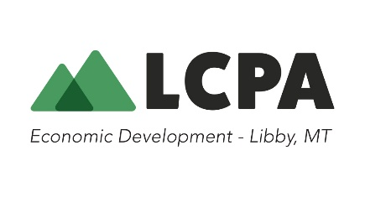
REQUEST FOR INFORMATION (RFI)
Wildfire Mitigation Project – Libby, Montana

Issuing Organization: Lincoln County Port Authority
Contact:
Jennifer Brown, Director
406-293-8406 or 406-405-9338
jenbrown@libby.org
216 West 9th Street - PO Box 1071
Libby, MT 59923

- Purpose

This Request for Information (RFI) is issued by Lincoln County Port Authority to gather information from qualified vendors, contractors, and agencies regarding their capabilities and interest in participating in future wildfire mitigation projects in Lincoln County, Montana. The purpose of this RFI is to identify contractors with the qualifications, capacity, and experience to perform wildfire mitigation duties aimed at reducing wildfire risk to residential areas, critical infrastructure, and natural resources.
This RFI is for planning purposes only and does not constitute a solicitation or a commitment to issue a future procurement.

- Project Background
Lincoln County, Montana, located within the Kootenai National Forest, is at a heightened risk of wildfire due to increased fuel loads, climate conditions, and topographical challenges. The area includes a mix of public and private lands with dense forest cover, steep terrain, and proximity to vulnerable communities.

Key project objectives include:
- Fuels reduction through hand thinning, mechanical thinning, prescribed burns, or mastication
- Defensible space creation near residential zones
- Vegetation management along utility corridors and access roads
- Emergency preparedness support.

- Requested Information
Respondents are invited to provide information on the following topics:
- Company Profile
  - Name, Location, Years in Business
  - Relevant licenses, certifications, and insurance
  - Experience with wildfire mitigation and related forestry work
- Technical Capabilities
  - Types of mitigation methods offered (i.e. thinning, prescribed burns, chipping, etc.)
  - Equipment inventory and crew sizes
  - GIS/mapping capabilities
- Logistical Considerations
  - Availability for work in northwest Montana

- Submission Instruction
Please submit your responses electronically in PDF or Word format to jenbrown@libby.org with the subject line “RFI Response – Wildfire Mitigation Project”, or mail to: LCPA, PO Box 1071, Libby, MT 59923, or hand deliver to: 216 W. 9th St., Libby, MT.

- Disclaimer
This RFI is issued solely for information and planning purposes and does not constitute a solicitation. Responses to this RFI will not be returned, and respondents will not be compensated. LCPA reserves the right to use any submitted information in the development of future solicitations.

