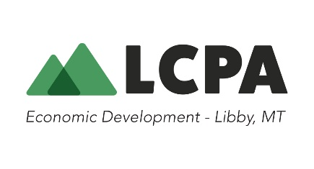
REQUEST FOR QUOTES
Wildfire Mitigation Project – Rexford Bench
RFQ Number: RFQ- 2026-01-WFM
Date Issued: June 5, 2026
Response Deadline: 12:00 p.m. MST June 22, 2026
Contact:
Jennifer Brown, Executive Director
406-293-8406 or 406-405-9338
jenbrown@libby.org
216 West 9th Street - PO Box 1071
Libby, MT 59923

Request for Quotes
Rexford Bench Fuels and Campground Clean-Up
Ksanka Ranger District

Background and Statement of Work: Lincoln County Port Authority (LCPA), in partnership with the USFS, is requesting quotes for vegetation management and hazardous fuels reduction services approximately six miles west of the town of Eureka, Montana. The project will involve thinning and bucking of small diameter trees and hand piling of the resultant slash and previously downed woody material over approximately 8.5 acres in one unit, bucking and hand piling (no thinning) of 2.5 acres over two units. Work will be completed in accordance with U.S. Forest Service specifications and under the supervision of designated LCPA and Forest Service personnel.

For full job description and quote submission requirements, contact Jennifer Brown: jenbrown@libby.org (406)405-9338.

